Planning Proposal to amend Greater Taree Local Environmental Plan 2010 to:

- Provide for realignment of Old Soldiers Road to provide a second access for the Hallidays Point Locality
- Rezone land to R5 and E2 to provide for development outcomes associated with the realignment of the road

Prepared by:

MidCoast Council
2 Pulteney Street
Taree NSW 2430

T: +61 (2) 7955 7763
E: council@midcoast.nsw.gov.au

Version 2020.1 / Date: December 2020

Table of contents
Introduction 5
Part 1 - Objectives or intended outcomes 6
Part 2 - Explanation of provisions 7
Part 3 - Justification 8
Section A – Need for the Planning Proposal 8
Section B – Relationship to Strategic Planning Framework 10
Section C – Environmental, Social and Economic Impact 15
Section D – State and Commonwealth Interests 18
Part 4 - Mapping 20
Part 5 - Community consultation 22
Part 6 - Project timeline 23
Part 7 - Conclusion 24
Appendix A – Consistency with Hunter Regional Plan Goals, Directions & Actions 25
Appendix B – Consistency with State Environmental Planning Policies 36
Appendix C – Consistency with S9.1 Ministerial Directions 39
Appendix D – Comments from Public Authorities consulted 43
Appendix E – Onsite Waste Water Management Report 44
Appendix F – Aboriginal Cultural Heritage Assessment 45
Appendix G – Contamination Assessment 46
Appendix H – Biodiversity Assessment 47

Version | Purpose of Document | Author | Date
1 | For Gateway Determination | GMS | December 2020
2 | Editorial amendments | xxx | xxx
3 | Minor editorial amendments to reflect Gateway Determination issued 2021 | xxx | xxx
4 | Amendments in response to public and agency submissions received during exhibition | xxx | xxx

Introduction
The Planning Proposal has been prepared by MidCoast Council in accordance with Division 3.4 of the Environmental Planning and Assessment Act 1979 and the relevant Department of Planning and Environment (Department) Guidelines, including A Guide to Preparing Local Environmental Plans and A Guide to Preparing Planning Proposals.
The Planning Proposal seeks to amend Greater Taree Local Environmental Plan (LEP) 2010 to:
- Amend the Greater Taree Local Environmental Plan 2010 Land Zoning Map to zone parts of the site R5 – Large Lot Residential and other areas E2– Environmental Conservation.
- Amend Greater Taree Local Environmental Plan 2010 Subdivision Lot Size Map to provide for smaller lot sizes (1 hectare) where land is zoned R5 for rural residential purposes.
- Amend Greater Taree Local Environmental Plan 2010 Height of Buildings Map to create an 8.5m maximum building height in areas to be zoned R5.
This Planning Proposal outlines the intended effect of, and justification for, the proposed amendments to Greater Taree LEP 2010.
The proposed amendments were the subject of a report to MidCoast Council, meeting
16 December 2020. The report, annexures and resolution relevant to this Planning Proposal are available on MidCoast Council's website.
The Gateway replaces a previous Gateway determination of 19 March 2015 to achieve the same objectives and outcomes.
The proclamation of 12 May 2016 ratified the merger of the Local Government Areas of Gloucester Shire, Greater Taree and Great Lakes into MidCoast Council. Greater Taree LEP 2010 still stands as a separate environmental planning instrument.

Part 1 - Objectives or intended outcomes
(s.3.33(2)(a) A statement of the objectives or intended outcomes of the proposed instrument)
The purpose of the Planning Proposal is to rezone land at Rainbow Flat to allow for rural residential development in a manner consistent with the outcomes of the Hallidays Point Development Strategy 2000, and to provide for a safe and effective secondary access for the Hallidays Point villages. The realignment of Old Soldiers Road through the land will replace an existing dangerous informal road through the adjoining nature reserve which is currently used by some parts of the community. The proposal provides a significant public benefit in that Council has identified the alignment of Old Soldiers Road through the land (as provided for in the proposal) as a key outcome in the relevant strategies. The creation of the road through the land provides for the provision of the essential second road link for Hallidays Point to complement effective growth of the land and provide for improved access in the event of an emergency.
The proposal will also identify important ecological values of the land and provide protective zoning to areas that are important as corridors and habitat areas.
In addition, the planning proposal will be undertaken in conjunction with a voluntary planning agreement which will provide for the dedication of land to National Parks where the Old Soldiers Road alignment will not form an edge between rural residential development and the nature reserve.
The intention is to amend Greater Taree Local Environmental Plan 2010 to:
- Amend the Greater Taree Local Environmental Plan 2010 Land Zoning Map to zone parts of the site R5 – Large Lot Residential and other areas E2– Environmental Conservation.
- Amend Greater Taree Local Environmental Plan 2010 Subdivision Lot Size Map to provide for smaller lot sizes (1 hectare) where land is zoned R5 for rural residential purposes.
- Amend Greater Taree Local Environmental Plan 2010 Height of Buildings Map to create an 8.5m maximum building height in areas to be zoned R5.

Part 2 - Explanation of provisions
(s.3.33(2)(b) An explanation of the provisions that are to be included in the proposed instrument)
The proposal will amend Greater Taree Local Environmental Plan 2010 in the following manner:

▪ Amendment of the Greater Taree Local Environmental Plan 2010 Land Zoning Map to zone parts of the site R5 – Large Lot Residential and other areas E2– Environmental Conservation.
▪ Amendment of the Greater Taree Local Environmental Plan 2010 Subdivision Lot Size Map to provide for smaller lot sizes (1 hectare) where land is zoned R5 for rural residential purposes.
▪ Amendment of the Greater Taree Local Environmental Plan 2010 Height of
Buildings Map to create an 8.5m maximum building height in areas to be zoned R5.

In addition, the planning proposal will be undertaken in conjunction with a planning agreement which will provide for the dedication of the reserve for the Old Soldiers Road link and construction requirements where the road is constructed as part of the land subdivision.
A planning agreement is also proposed for the dedication of an area of land proposed to be zoned E2 to the adjoining nature reserve.

Part 3 - Justification
(s.3.33(2)(c) Justification for the objectives or intended outcomes and the process for their implementation)

Section A – Need for the Planning Proposal
3.A.1 Is the Planning Proposal a result of any strategic study or report?
The planning proposal provides for rural residential use of the land consistent with the outcomes of the Hallidays Point Conservation and Development Strategy 2000, which was adopted by Council and endorsed by the Department of Urban Affairs and Planning in January 2000.
Council has also undertaken an Options Analysis Report for the realignment of Old Soldiers Road which identified this as the preferred outcome if the NSW National Parks decline realigning the road through the adjoining nature reserve. Recent discussions with National Parks have resulted in the preferred option being connection of Old Soldiers Road through the site to the north eastern corner of Lot 5 and then being connected along the eastern boundary of the nature reserve.
The planning proposal is consistent with the MidCoast Local Strategic Planning Statement Planning Priorities to:

- Deliver housing supply, choice and diversity.
- Connect people and places.
- Protect and improve our environment.
- Improve our resilience.
- Manage land and water assets.
- Improve our infrastructure and become a location of choice.
- Leverage our lifestyle and amenity.

3.A.2 Is the Planning Proposal the best means of achieving the objectives or intended outcomes, or is there a better way?
The key result of creating an alternate access for Old Soldiers Road would involve either:

- Constructing the road in existing road reserves around the nature reserve.
- Undertaking a compulsory acquisition of the road through the subject land.
The first option is not considered appropriate as the route is currently forested and would result in clearing a large swathe of land through the nature reserve and regional corridor. The route would also require significant earthworks which may not be able to be contained within the existing road reserves.
Compulsory acquisition of the land is not favoured and would require a suitable acquisition zone, as well as government authority which would be subject to extended time and cost to determine suitable compensation. The preferred approach delivers an appropriate development opportunity over capable land in return for the dedication of the road corridor. The proposed approach is considered the best way to achieve the desired outcomes.

Section B – Relationship to Strategic Planning Framework
3.B.1 Is the Planning Proposal consistent with the objectives and actions contained within the applicable regional or sub-regional strategy (including the Sydney Metropolitan Strategy and exhibited draft strategies)?
The proposal is consistent with the aims and objectives of the Department of Planning and Infrastructure’s Mid North Coast Regional Strategy 2006-31. The Regional Strategy provides a series of principles for Rural Residential Growth, and the proposed rezoning is consistent with these principles.
In relation to these principles, the subject land:
• Is located in an area adjoining Diamond Beach and among other rural residential developments connected to the Hallidays Point locality.
• Is in an approved current rural residential land release strategy.
• Is not in an area identified for future urban expansion.
• Development can occur on parts of the site previously cleared and disturbed and not require significant clearing.
• Does not have high primary production values.
• Includes some areas that may be valuable from a biodiversity perspective. These will be identified and appropriately zoned.
The Strategy also provides a series of actions in relation to rural residential development as follows:
• Future rural residential land will only be zoned for release if it is in accordance with a local growth management strategy agreed to between council and the Department of Planning and consistent with the principles of the Settlement Planning Guidelines.

• No new rural residential development will be permitted within the Coastal Area, other than development already zoned or in an approved current or future local growth management strategy (or rural residential land release strategy).

• Planning for rural residential land must be integrated with the supply of infrastructure and transport.
In relation to these actions:
• The subject land is identified for Phase 1 rural residential growth in the Hallidays Point Development Strategy 2000 and the Greater Taree Rural Residential Strategy and Release Program 2002. Both these strategies have been adopted by Council and endorsed by the Department of Planning (in its various guises).
• The proposal integrates with an important transport outcome by facilitating the missing second traffic link for Hallidays Point.
The Planning Proposal is considered to be generally consistent with the objectives and actions contained within the Hunter Regional Plan 2036. A summary of the Planning Proposal’s consistency is provided in Appendix A of this Planning Proposal.

3.B.2 Is the Planning Proposal consistent with the local council’s Community Strategic Plan, or other local strategic plan?
Mid Coast 2030 Community Strategic Plan
The Mid Coast 2030 Community Strategic Plan (CSP) is a roadmap for the future of the Mid Coast. In the development of this Plan, other key government plans and legislative frameworks were considered; in particular NSW State Plan, the Hunter Regional Plan, the Local Government Act 1993 and the Integrated Planning and Reporting Guidelines, to ensure that there is alignment and the community is working towards a shared vision.
The Vision of the CSP is:
“We aspire to be a place of unique environmental significance where our quality of life and sense of community is balanced by sustainable and sensitive development, which fosters economic growth”
The most relevant values of the CSP are:
It is safe and easy to get around our region
- Plan for, provide and maintain a safe road network that meets current and future needs.
The proposal facilitates the second road access which is necessary for the ongoing safety and growth of the Hallidays Point locality.
We balance the needs of our natural and built environments
- Ensure growth and new development complements our existing natural assets and heritage sites.
- Optimise land use to meet our environmental, social and development needs.
The new development opportunities that will be created by the implementation of the planning proposal will protect environmentally valuable areas and facilitate a much needed second access to the Hallidays Point urban area.
Overall, this Planning Proposal is consistent with the values of the CSP.
Hallidays Point Development Strategy 2000
The Department of Planning and Infrastructure endorsed the Hallidays Point Development Strategy 2000 and, since then, Council adopted the Hallidays Point Conservation and Development Strategy Review in May 2006. Both the strategy and the review identified the land as Phase 1 – Rural Residential, being an area, which could proceed to rezoning.
The release is also recognised in the Rural Residential Strategy and Release Program
2002, again as a Phase 1 area.

The proposal is consistent with both these local strategies.
3.B.3 Is the Planning Proposal consistent with applicable state environmental planning policies?
The Planning Proposal is considered to be generally consistent with applicable state environmental planning policies.
A summary of the Planning Proposal’s consistency with applicable State Environmental Planning Policies is provided in Appendix B of this Planning Proposal.

3.B.4 Is the Planning Proposal consistent with applicable Ministerial Directions (s.9.1 directions)?
The Planning Proposal is considered to be generally consistent with applicable s.9.1 Ministerial Directions.
A summary of the Planning Proposal’s consistency with relevant s.9.1 Ministerial Directions is provided in Appendix C of this Planning Proposal.

Section C – Environmental, Social and Economic Impact
3.C.1 Is there any likelihood that critical habitat or threatened species, populations or ecological communities, or their habitats, will be adversely affected as a result of the proposal?
The subject land which is affected by the planning proposal contains varied vegetation communities that have resulted from previous disturbance of the land. The site includes large areas of cleared land that have been used for grazing and rural living purposes. These are the areas which would predominantly be utilised for rural residential purposes. There are some woodland areas which have resulted from past clearing and ongoing disturbance which may also be suitable for rural residential occupation. Parts of the site contain forest vegetation which may provide habitat for threatened species.
Areas of Lot 5 include koala habitat areas and a DCP for the land will provide for effective koala management for the land, including a koala plan of management.
Ecological investigations for the land have identified some corridors to be protected/enhanced. The ecological investigations have included a preliminary BDAR for the possible future development of the land.
The planning agreement for Lot 5 will also provide for the dedication of land to add to the adjoining nature reserve providing an improvement in habitat areas of publicly protected land and offsetting impacts in other parts of the site.

3.C.2 Are there any other likely environmental effects as a result of the Planning Proposal and how are they proposed to be managed?
To prevent impacts to local water quality, an on-site sewerage management investigation has been undertaken which shows the land can cater for suitable effluent disposal with a minimum allotment size of 1 hectare.
The subject land is bushfire prone and a bushfire assessment has shown the land can be developed in accordance with the NSW Rural Fire Service Guideline Planning for Bush Fire Protection 2019. The proposed linkage of the road to create a safe second access to the Hallidays Point area will improve emergency management in the area and consultation with the NSW Rural Fire Service has advised no objections to the proposal.
Contamination has been investigated through geotechnical assessment which has determined that the land is suitable for the proposed use, subject to further investigation and remediation of some small localised areas of Lots 4 and 5. These areas can be further examined/remediated as part of the future development of the land and will be notified in the DCP to be prepared for the land.

3.C.3 Has the Planning Proposal adequately addressed any social and economic effects?
The Planning Proposal will provide for planned growth in the Hallidays Point area which will support economic activities in the area and provide for additional population in support of community facilities such as schools, churches, community organisations, etc.
The proposal provides for the creation of a safe and efficient second access from the Hallidays Point urban areas to The Lakes Way. The second access provides advantages in terms of providing shorter travel distances to Taree, reducing traffic volumes along Blackhead Road and Diamond Beach Road, providing enhanced access for emergency services (such as the Rural Fire Service) and providing an alternate route should Blackhead Road be closed. The existing informal track through the nature reserve is currently used by the community as a shortcut from Hallidays Point/Diamond Beach to Taree. In addition, the track is used by tourists accessing the resorts at North Diamond Beach and accidents and vehicle damage on the track is common.
The provision of a formal well-constructed road will be much safer than the existing informal access road through the Nature Reserve which is frequently used for this purpose. Council has been pressing for action on this road for 20 years, and the formalisation and upgrade of this road are important for the local community. The proposed rezoning facilitates the provision of this second access and provides a net community benefit.

The proposal also provides a corridor for secondary linking of services such as water and electricity supply which currently only have one main in. Both MidCoast Water and Essential Energy have expressed a desire to connect a secondary main through this corridor and a net community benefit can be provided through securing ongoing supply of essential services.

An Aboriginal Cultural Heritage Assessment has been undertaken for the land. Two areas of Potential Archaeological Deposits have been identified along two creeks within the area. The area can be developed in a manner minimising disturbance of these areas, and any works in these areas will require further investigation. This requirement will be confirmed in the DCP to be developed for the land.

Section D – State and Commonwealth Interests
3.D.1 Is there adequate public infrastructure for the Planning Proposal?
The proposal will require extension and augmentation of electricity and telecommunications services that are available in the area. Reticulated sewerage services are not available at the land and development will rely on on-site disposal of effluent.

Water main services may be provided to future development on the land and the proposal may facilitate additional main connection between water reservoirs and the Hallidays Point trunk main system, providing benefits in terms of supply security to the existing and future development in the area.

The road corridor also provides opportunity for a second electricity connection to the Hallidays Point/Diamond Beach network and which will assist in security of supply to existing and future development in the area.

The proposal facilitates a second access between the Hallidays Point urban areas and The Lakes Way, which provides improved access and more efficient delivery of public services, including emergency services.

The proposal will utilise public services and amenities provided within the Hallidays Point and Taree areas and will contribute to the provision of these facilities through Section 94 contributions.

Consultation has been undertaken with State and Commonwealth agencies regarding the public infrastructure requirements of the Planning Proposal.
3.D.2 What are the views of State and Commonwealth public authorities consulted in accordance with the Gateway Determination?
The previous Gateway underwent consultation with the following agencies:
Agency | Issue | Response
NSW Rural Fire Service | Consultation as land is mapped as Bushfire Prone Land | No objection
Office of Environment and Heritage | Biodiversity requirements | Ongoing discussions
National Parks and Wildlife | Road alignment and route | Ongoing discussions
Water Services | Provision of water supply | No objection

The comments provided are contained within Appendix D of this Planning Proposal.
The following public agencies have been identified for consultation following a new Gateway determination:
- NSW Office of Environment and Heritage
- Department Primary Industries
- Essential Energy
- Telstra
Should the Proposal be significantly amended as a result of agency consultation, it may be reported back to Council and the Department of Planning, Industry and Environment for an amended Gateway Determination.

Part 4 - Mapping
(s.55(2)(d) Maps to be adopted by the proposed instrument)
The proposal will require amendments to existing maps as follows.
- Greater Taree LEP 2010 Land Zoning Map 15B
Existing Zone Map  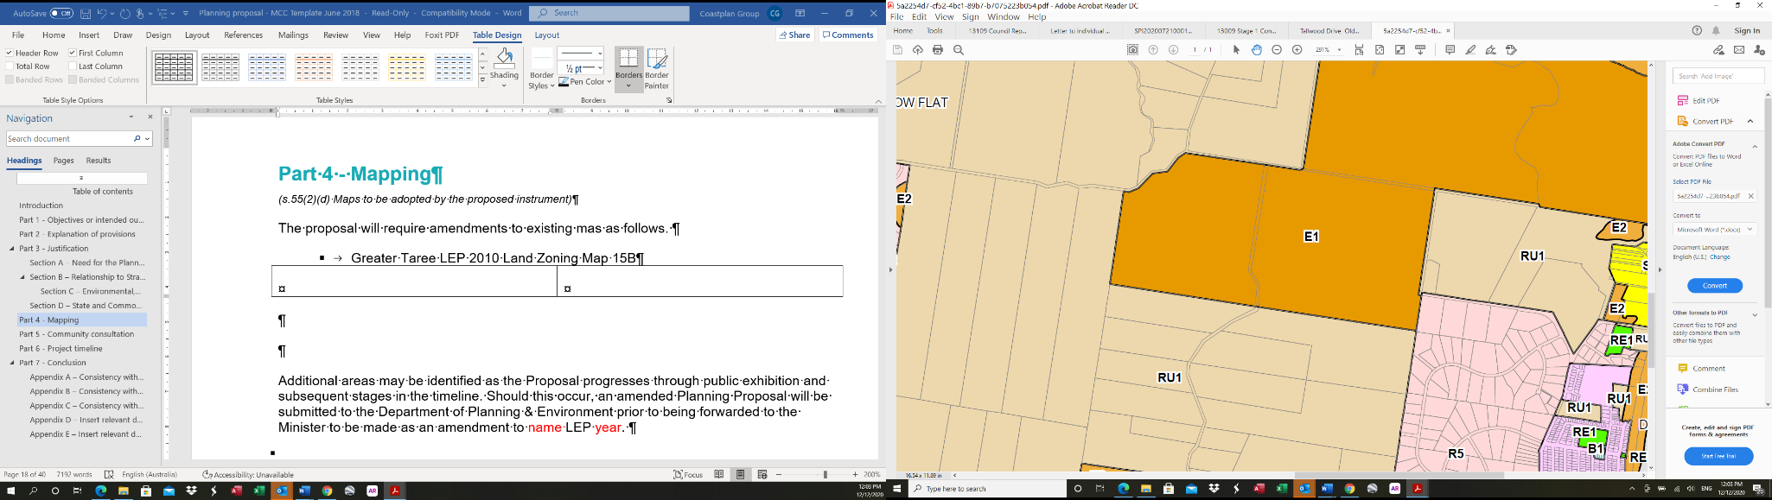 | Proposed Zone Map  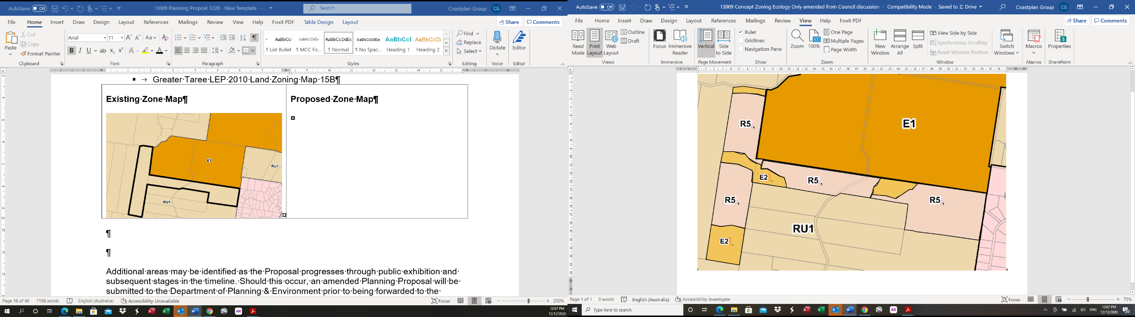
- Greater Taree LEP 2010 Lot Size Map 15B
Existing Lot Size Map  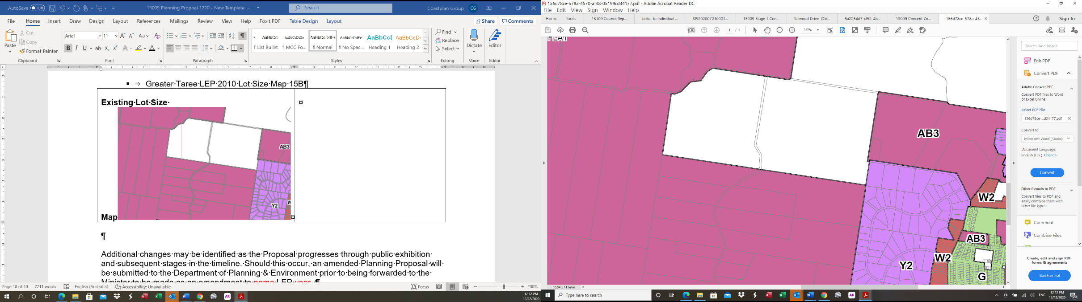 | Proposed Lot Size Map  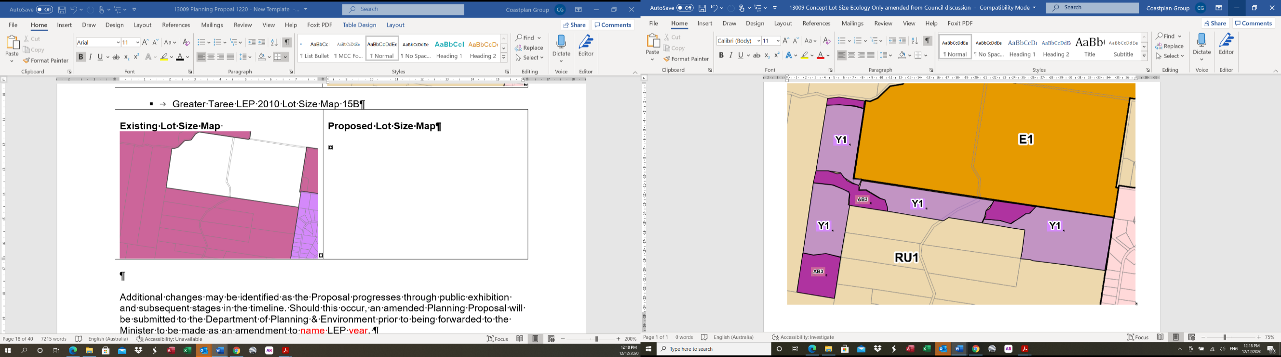
Y1 – 1 hectare
AB3 – 40 hectares

- Greater Taree LEP 2010 Height of Buildings Map 15B
Existing Height of Buildings Map  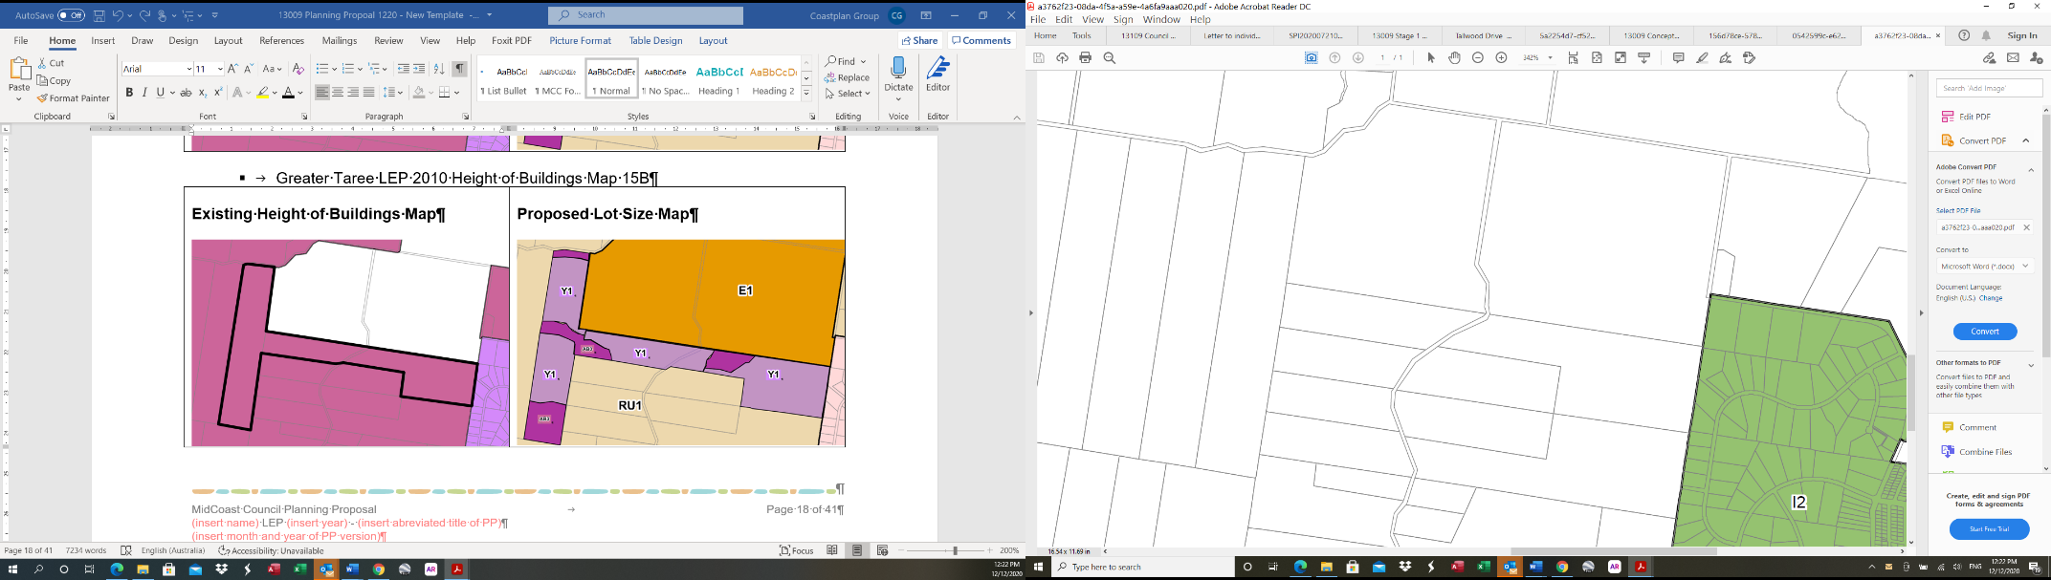 | Proposed Height of Buildings Map  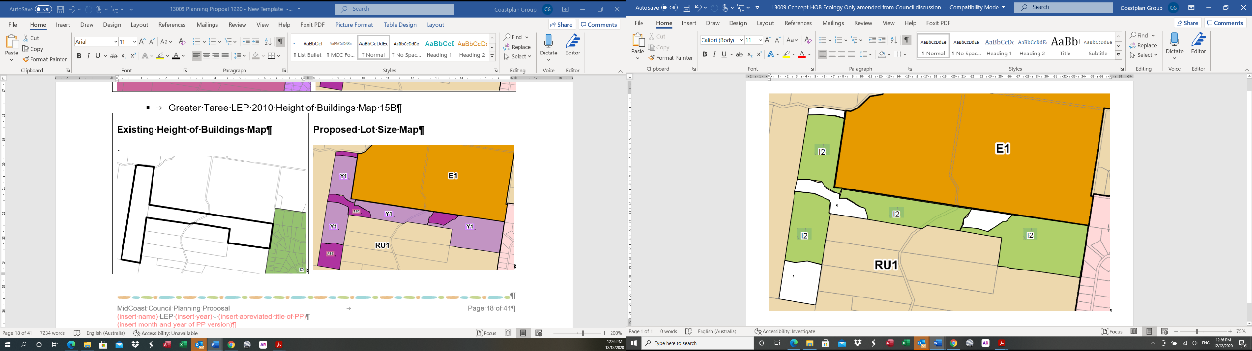
I2 – 8.5m
Additional changes may be identified as the Proposal progresses through public exhibition and subsequent stages in the timeline. Should this occur, an amended Planning Proposal will be submitted to the Department of Planning, Industry and Environment prior to being forwarded to the Minister to be made as an amendment to Greater Taree LEP 2020.

Part 5 - Community consultation
In accordance with Section 3.34(2)(c)of the Environmental Planning and Assessment Act 1979, this Planning Proposal will be made publicly available for a minimum of 28 days.
In accordance with Council’s adopted consultation protocols the following will also be undertaken:
- Notices in the local newspaper;
- Direct mail notification to potentially affected landowners;
- Exhibition material and all relevant documents will be available at Council’s Administrative and District Offices;
- Exhibition material and all relevant documents will be available on Council’s website.
Any further consultation required by the Gateway Determination will also be undertaken.

Part 6 - Project timeline
In accordance with the Department of Planning and Environment guidelines, the following timeline is provided, which includes the tasks deemed necessary for the making of this local environmental plan.

Task | Responsibility | Timeframe | Date  (approximate)
Council resolution to support the Planning Proposal | Council | - | 16 December 2020
Lodgement of Planning Proposal for Gateway Determination | Council | - | December 2020
Gateway Determination Issued | Minister for Planning | - | January 2021
Consultation with Public Authorities in accordance with Gateway Determination | Council | Minimum 21 days | March 2021
Public exhibition of Planning Proposal | Council | Minimum 28 days | June 2021
Report to Council | Council | - | December 2021
Lodgement of Planning Proposal (with any amendments as a result of submissions) | Council | - | February 2022
Making of local environmental plan | Minister for Planning | 6 – 8 weeks | May 2022

Part 7 - Conclusion
The primary aims of the Planning Proposal are to amend the existing maps, development of Greater Taree Local Environmental Plan (LEP) 2010 to:
- Amend the Greater Taree Local Environmental Plan 2010 Land Zoning Map to zone parts of the site R5 – Large Lot Residential and other areas E2– Environmental Conservation.

- Amend Greater Taree Local Environmental Plan 2010 Subdivision Lot Size Map to provide for smaller lot sizes (1 hectare) where land is zoned R5 for rural residential purposes.

- Amend Greater Taree Local Environmental Plan 2010 Height of Buildings Map to create an 8.5m maximum building height in areas to be zoned R5.
The Proposal is considered to have strategic merit being consistent with the local planning strategies for the area and delivering net community benefits with the realignment of Old Soldiers Road to create a suitable second access for the Hallidays Point urban areas.

Appendix A – Consistency with Hunter Regional Plan Goals, Directions & Actions

Goal 1 – the leading regional economy in Australia
Direction 4 – Enhance inter-regional linkages to support economic growth
Action 4.1 Enhance inter-regional transport connections to support economic growth. | Not Applicable
Action 4.2 Work with stakeholders to upgrade transport network capacity in line with changing demands. | Not Applicable
Action 4.3 Strengthen and leverage opportunities from the interconnections with other regions, particularly the Pacific Highway, the Golden Highway and the New England Highway. | Not Applicable
Action 4.4 Promote freight facilities that leverage the Port of Newcastle and its associated freight transport network. | Not Applicable
Action 4.5 Plan for multimodal freight facilities that support economic development of the region and respond to the location of the proposed Freight Rail Bypass. | Not Applicable
Action 4.6 Investigate opportunities for logistics and freight growth and other complementary land uses around airports, leveraging investments at Taree and Newcastle airports. | Not Applicable
Action 4.7 Enhance the efficiency of existing nationally significant transport corridors and protect their intended use from inappropriate surrounding land uses. | Not Applicable
Action 4.9 Balance competing interests and deliver conservation, transport and land use planning objectives in the national pinch point area by:  - Identifying preferred habitat corridors and priorities for investment in conservation to sustain habitat connectivity; and  - Developing an integrated management plan for the area. | Not Applicable
Direction 6 – Grow the economy of MidCoast and Port Stephens
Action 6.1 Enhance tourism infrastructure and connectivity, recognising the importance of:  - regional and inter-regional connections via the Pacific Highway and the Newcastle and Taree airports and cruise ship gateways; and  - local routes such as The Lakes Way and Nelson Bay Road. | The proposal will enhance connectivity and road infrastructure for the Hallidays Point Locality through creation of a suitable second access to the urban area.
Action 6.2 Enhance links to regional services in Greater Newcastle. | Not Applicable
Action 6.3 Enable economic diversity and new tourism opportunities that focus on reducing the impacts of the seasonal nature of tourism and its effect on local economies. | The proposed secondary access will enhance connection for tourism in the Hallidays Point area.
Action 6.4 Promote growth of industries that can leverage accessibility provided by the Pacific Highway. | Not Applicable
Action 6.5 Plan for and provide infrastructure and facilities that support the ageing population. | Not Applicable
Direction 7: Develop advanced manufacturing, defence and aerospace hubs
Action 7.2 Grow and diversify the manufacturing sector through local planning and appropriate planning controls. | Not Applicable
Action 7.3 Promote manufacturing business export opportunities and become part of global supply chains. | Not Applicable
Action 7.4 Facilitate research partnerships between tertiary education providers and businesses. | Not Applicable
Direction 8 – Promote innovative small business and growth in the service sectors
Action 8.1 Implement initiatives to promote small business growth and innovation, particularly in Newcastle City centre and other strategic centres. | Not Applicable
Action 8.2 Facilitate opportunities for incubator spaces for technology and non-technology early stage businesses, and ensure opportunities for new and emerging enterprises are encouraged. | Not Applicable
Action 8.3 Improve connectivity to the region’s major health and education precincts and strategic centres. | Not Applicable
Action 8.5 Establish a health precinct around Metford and other hospitals in the region, including Manning Base Hospital at Taree. | Not Applicable

Direction 9 – Grow tourism in the region
Action 9.1 Enable investment in infrastructure to expand the tourism industry, including connections to tourism gateways and attractions. | Not Applicable
Action 9.2 Encourage tourism development in natural areas that support conservation outcomes. | Not Applicable
Action 9.5 Develop capacity for growth in food-based tourism in the region. | Not Applicable
Direction 10 – Protect and enhance agricultural productivity
Action 10.1 Protect locations that can accommodate agricultural enterprises from incompatible development, and facilitate the supply chain, including infrastructure, distribution areas, processing facilities and research and development in local plans. | Not Applicable
Action 10.2 Address sector-specific considerations for agricultural industries through local plans. | Not Applicable
Action 10.3 Protect the region’s wellbeing and prosperity through increased biosecurity measures. | Not Applicable
Action 10.4 Encourage niche commercial, tourist and recreation activities that complement and promote a stronger agricultural sector, and build the sector’s capacity to adapt to changing circumstances. | Not Applicable
Action 10.6 Manage Biophysical Strategic Agricultural Land and other important agricultural land as locations for agricultural activities and complementary uses. | Not Applicable
Direction 11 – Manage the ongoing use of natural resources
Action 11.1 Manage the ongoing use of mineral resources and provide access to up-to-date information about these resources through the Department of Industry’s Common Ground website and its Geoscientific Data Warehouse. | Not Applicable
Action 11.2 Work with relevant stakeholders including councils, communities and industry, to prepare land use plans that respond to the lifecycle of resource activity for active and emerging mining areas. | Not Applicable
Action 11.3 Implement the cumulative impact assessment methodology when planning for important agricultural land and water resources. | Not Applicable
Action 11.4 Review the Synoptic Plan: Integrated Landscapes for Coal Mine Rehabilitation in the Hunter Valley (1999) in conjunction with the development of the Upper Hunter Strategic Biodiversity Assessment to ensure best-practice rehabilitation and visual impact management for closed mines. | Not Applicable
Direction 12: Diversify and grow the energy sector
Action 12.1 Diversify and grow the energy sector by working with stakeholders, including councils, communities and industry, to identify and support opportunities for smaller-scale renewable energy initiatives such as those using bioenergy or waste coalmine methane. | Not Applicable
Action 12.2 Enable new opportunities for renewable energy industries by reviewing local planning controls. | Not Applicable
Action 12.3 Promote new opportunities arising from the closure of coalfired power stations that enable long term sustainable economic and employment growth in the region. | Not Applicable
Direction 13 – Plan for greater land use compatibility
Action 13.1 Identify and protect important agricultural land, including intensive agriculture clusters, in local plans to avoid land use conflicts, particularly associated with residential expansion. | Not Applicable
Action 13.2 Limit urban and rural housing encroachment into identified agricultural and extractive resource areas, industrial areas, and transport infrastructure when preparing local strategies. | Not Applicable
Action 13.3 Amend planning controls to deliver greater certainty of land use. | Not Applicable
Action 13.4 Provide non-statutory guidance on the types of land uses that would be considered most appropriate, suitable or sympathetic with existing land uses in the Upper Hunter and other areas where land use conflicts occur. | Not Applicable

Goal 2 – A biodiversity-rich natural environment
Direction 14 – Protect and connect natural areas
Action 14.1 Identify terrestrial and aquatic biodiversity values and protect areas of high environmental value to sustain the lifestyle, economic success and environmental health of the region. | Not Applicable
Action 14.2 Identify and strengthen biodiversity corridors as places for priority biodiversity offsets. | Not Applicable
Action 14.3 Improve the quality of, and access to, information relating to high environmental values. | Not Applicable
Action 14.4 Protect biodiversity by maintaining and, where possible, enhancing existing protection of high environmental value areas; implementing appropriate measures to conserve validated high environmental value areas; developing local strategies to avoid and minimise the impacts of development on areas of high environmental value and biodiversity corridors; and identifying offsets or other mitigation measures for unavoidable impacts. | Not Applicable
Action 14.5 Secure the long term protection of regionally significant biodiversity corridors. | Not Applicable
Direction 15: Sustain water quality and security
Action 15.1 Protect water catchments to sustain high quality and dependable water supplies across the region. | Not Applicable
Action 15.2 Effectively manage surface and groundwater use in agricultural areas to support ecosystem function, food production, and to cater for the increasing demand of urban communities and industry. | Not Applicable
Action 15.3 Plan for the security of the region’s town water supply. | Not Applicable
Action 15.4 Implement catchment-based plans for the ongoing sustainable management and health of estuaries. | Not Applicable
Action 15.5 Apply the neutral or beneficial water quality objectives to land use planning in surface and groundwater drinking water catchment areas to minimise the effects of development on waterways, including watercourses, wetlands, groundwater dependent ecosystems, riparian lands, estuaries, lakes, beaches and marine waters. | Not Applicable
Action 15.6 Reduce the risk of introduction or spread of aquatic pests and diseases from new development that may affect fisheries and aquaculture industry practices. | Not Applicable
Action 15.7 Incorporate water-sensitive design into development that is likely to have an adverse impact on coastal water catchments, water quality and flows. | Not Applicable
Direction 16: Increase resilience to hazards and climate change
Action 16.1 Manage the risks of climate change and improve the region’s resilience to flooding, sea level rise, bushfire, mine subsidence and land contamination. | Not Applicable
Action 16.2 Review and consistently update floodplain risk and coastal zone management plans, particularly where urban growth is being investigated. | Not Applicable
Action 16.3 Incorporate new knowledge on regional climate projections and related cumulative impacts in local plans for new urban development. | Not Applicable
Action 16.4 Review and update the Newcastle Mines Grouting Fund and investigate its relevance to other areas. | Not Applicable
Goal 3 – Thriving communities
Direction 17: Create healthy built environments through good design
Action 17.1 Develop best-practice guidelines for planning, designing and developing healthy built environments. | The second access to the Hallidays Point locality is an important link for the safety and wellbeing of the area.
Action 17.2 Enhance access to fresh food by promoting initiatives that increase urban food production and access to produce from local farmers. | Not Applicable
Action 17.3 Enhance the quality of neighbourhoods by integrating recreational walking and cycling networks into the design of new communities to encourage physical activity. | Not Applicable
Direction 18: Enhance access to recreational facilities and connect open space
Action 18.1 Facilitate more recreational walking and cycling paths including planning for the Richmond Vale Rail Trail and expanded inter-regional and intra-regional walking and cycling links, including the NSW Coastal Cycleway. | Not Applicable
Action 18.2 Deliver connected biodiversity-rich corridors and open space areas for community enjoyment. | The proposal includes establishment of corridors for the connectivity of bushland areas.
Action 18.3 Enhance public access to natural areas, including coastal and lake foreshores. | Not Applicable
Action 18.4 Assist councils to develop open space and recreation strategies that identify a range of accessible open space and recreation opportunities; integrate open space, active transport and recreation networks; and improve public foreshore access. | Not Applicable
Action 18.5 Implement actions and invest in boating infrastructure priorities identified in regional boating plans to improve boating safety, boat storage and waterway access. | Not Applicable
Direction 19 – Identify and protect the region’s heritage
Action 19.1 Consult with the local Aboriginal communities to identify and protect heritage values to minimise the impact of urban growth and development, and to recognise their contribution to the character and landscape of the region. | The proposal has undergone Aboriginal Heritage Assessment which has included consultation with Aboriginal groups.
Action 19.2 Assist the preparation of appropriate heritage studies to inform the development of strategic plans, including regional Aboriginal cultural heritage studies. | Not Applicable
Direction 20: Revitalise existing communities
Action 20.1 Accelerate urban revitalisation by directing social infrastructure where there is growth. | Not Applicable
Action 20.2 Undertake planning and place-making for main streets and centres. | Not Applicable
Action 20.3 Enhance the amenity and attractiveness of existing places. | Not Applicable
Goal 4 – Greater housing choice and jobs
Direction 21: Create a compact settlement
Action 21.1 Promote development that respects the landscape attributes and the character of the metropolitan area, towns and villages. | Not Applicable
Action 21.2 Focus development to create compact settlements in locations with established services and infrastructure, including the Maitland Corridor growth area; Newcastle–Lake Macquarie Western Corridor growth area; the emerging growth area around Cooranbong, Morisset and Wyee; and in existing towns and villages, and sites identified in an endorsed regional or local strategy. | Not Applicable
Action 21.4 Create a well-planned, functional and compact settlement pattern that responds to settlement planning principles and does not encroach on sensitive land uses, including land subject to hazards, on drinking water catchments or on areas with high environmental values. | Not Applicable
Action 21.5 Promote small-scale renewal in existing urban areas, in consultation with the community and industry to ensure that this occurs in the right locations. | Not Applicable
Action 21.6 Provide greater housing choice by delivering diverse housing, lot types and sizes, including small-lot housing in infill and greenfield housing locations. | Not Applicable
Action 21.7 Promote new housing opportunities in urban areas to maximise the use of existing infrastructure. | Not Applicable
Direction 22: Promote housing diversity
Action 22.1 Respond to the demand for housing and services for weekend visitors, students, seasonal workers, the ageing community and resource industry personnel. | Not Applicable
Action 22.2 Encourage housing diversity including studio and one and two-bedroom dwellings, to match forecast changes in household sizes. | Not Applicable
Action 22.3 Develop local housing strategies to respond to housing needs, including social and affordable housing, and support initiatives to increase the supply of affordable housing. | Not Applicable
Action 22.4 Develop Settlement Planning Principles and a local planning toolkit to assist councils in implementing the Plan. | Not Applicable
Action 22.5 Include guidance in local land use strategies for expanding rural villages and rural residential development so that future rural residential development will:  - not impact on strategic or important agricultural land, energy, mineral or extractive resource viability or biodiversity values;  - not impact on drinking water catchments;  - not result in greater natural hazard risk;  - occur on land that is unlikely to be needed for urban development;  - contribute to the conservation of important biodiversity values or the establishment of important corridor linkages; and  - facilitate expansion of existing and new tourism development activities in agricultural or resource lands and related industries across the region. | Not Applicable
Direction 23 – Grow centres and renewal corridors
Action 23.1 Concentrate growth in strategic centres, local centres and urban renewal corridors to support economic and population growth and a mix of uses. | Not Applicable
Action 23.2 Develop precinct plans for centres to take an integrated approach to transport, open space, urban form and liveable neighbourhoods, and investigate the capacity of centres to accommodate additional housing and diversity, without compromising employment growth. | Not Applicable
Action 23.3.Consider improvements to the public transport network when planning new renewal corridors and precincts. | Not Applicable
Action 23.4 Investigate locations for new and expanded centres, including within the Newcastle – Lake Macquarie Western Corridor and Maitland Corridor growth areas, and in the established urban areas that are projected to have high demand for housing growth is projected. | Not Applicable
Action 23.5 Focus commercial and retail development within existing centres and transport hubs and ensure that locations for new centres are integrated with existing or planned residential development; do not undermine existing centres; encompass high quality urban design; and consider transport and access requirements. | Not Applicable
Direction 24 – Protect the economic functions of employment land
Action 24.1 Locate new employment land so that it does not conflict with surrounding residential uses. | Not Applicable
Action 24.2 Protect the economic functions of employment land by not permitting non-industrial uses unless:  - opportunities for urban renewal arise through the relocation of industry and in locations well serviced by public transport; and  - contaminated land can be remediated. | Not Applicable
Action 24.3 Provide for mixed use opportunities and themed employment precincts in local plans. | Not Applicable
Direction 25 – Monitor housing and employment supply and demand
Action 25.1 Establish and implement an Urban Development Program to develop data on existing zoned land supply and its servicing status, monitor dwelling production and take-up rates, and coordinate the staged release and rezoning of land. | Not Applicable
Action 25.2 Establish and implement an Employment Lands Development Program to develop data on existing and future planned stocks of employment land. | Not Applicable
Action 25.3 Sequence new greenfield urban development that makes efficient use of infrastructure networks and capacity. | Not Applicable
Action 25.4 Maintain an adequate supply of employment land that is appropriately serviced and to respond to changing industry demands for land use, location and floor space. | Not Applicable
Direction 26 – Deliver infrastructure to support growth and communities
Action 26.1 Align land use and infrastructure planning to maximise the use and capacity of existing infrastructure and the efficiency of new infrastructure. | The proposal provides growth opportunities that deliver road access with a second access to the Hallidays Point urban areas.
Action 26.2 Enable the delivery of health facilities, education, emergency services, energy production and supply, water and waste water, waste disposal areas, cemeteries and crematoria, in partnership with the infrastructure providers. | Not Applicable
Action 26.3 Protect existing and planned major infrastructure corridors and sites, including inter-regional transport routes like the M1 Pacific Motorway and the railway, port and airport, to support their intended function. | Not Applicable
Action 26.4 Coordinate the delivery of infrastructure to support the timely and efficient release of land for development, including working with councils and service providers on inter-regional infrastructure and service delivery issues between growing areas. | Not Applicable
Action 26.5 Ensure growth is serviced by enabling and supporting infrastructure. | Not Applicable
Action 26.6 Review and finalise the Hunter Special Infrastructure Contributions Plan. | Not Applicable
Direction 27: Strengthen the economic self-determination of Aboriginal communities
Action 27.1 Work with the Purfleet–Taree, Forster, Karuah, Worimi, Mindaribba, Awabakal, Bahtabah, Biraban and Wanaruah Local Aboriginal Land Councils to identify priority sites that can create a pipeline of potential Initiatives. | The proposal has undergone Aboriginal Heritage Assessment which has included consultation with Aboriginal groups.
Action 27.2 Identify landholdings and map the level of constraint at a strategic scale for each site to develop options for the potential commercial use of the land. | Not Applicable

Appendix B – Consistency with State Environmental Planning Policies

State Environmental Planning Policy (SEPP) | Issue 1 | Issue 2
SEPP No 1 —Development Standards | Not applicable | Not applicable
SEPP No 19—Bushland in Urban Areas | Not applicable | Not applicable
SEPP No 21—Caravan Parks | Not applicable | Not applicable
SEPP No 33—Hazardous and Offensive Development | Not applicable | Not applicable
SEPP No 36—Manufactured Home Estates | Not applicable | Not applicable
SEPP No 47—Moore Park Showground | Not applicable | Not applicable
SEPP No 50—Canal Estate Development | Not applicable | Not applicable
SEPP No 55—Remediation of Land | Investigations of the land have been undertaken which have identified the land is suitable or can be remediated to be suitable for proposed residential use.
SEPP No 64—Advertising and Signage | Not applicable | Not applicable
SEPP No 65—Design Quality of Residential Apartment Development | Not applicable | Not applicable
SEPP No 70—Affordable Housing (Revised Schemes) | Not applicable | Not applicable
SEPP (Affordable Rental Housing) 2009 | Not applicable | Not applicable
SEPP (Building Sustainability Index: BASIX) 2004 | Not applicable | Not applicable
SEPP (Exempt and Complying Development Codes) 2008 | Not applicable | Not applicable
SEPP (Housing for Seniors or People with a Disability) 2004 | Not applicable | Not applicable
SEPP (Infrastructure) 2007 | Consultation will occur with service providers.
SEPP (Integration and Repeals) 2016 | Not applicable | Not applicable
SEPP (Kosciuszko National Park—Alpine Resorts) 2007 | Not applicable | Not applicable
SEPP (Kurnell Peninsula) 1989 | Not applicable | Not applicable
SEPP (Mining, Petroleum Production and Extractive Industries) 2007 | Not applicable | Not applicable
SEPP (Miscellaneous Consent Provisions) 2007 | Not applicable | Not applicable
SEPP (Penrith Lakes Scheme) 1989 | Not applicable | Not applicable
SEPP (State and Regional Development) 2011 | Not applicable | Not applicable
SEPP (State Significant Precincts) 2005 | Not applicable | Not applicable
SEPP (Sydney Drinking Water Catchment) 2011 | Not applicable | Not applicable
SEPP (Sydney Region Growth Centres) 2006 | Not applicable | Not applicable
SEPP (Three Ports) 2013 | Not applicable | Not applicable
SEPP (Urban Renewal) 2010 | Not applicable | Not applicable
SEPP (Western Sydney Employment Area) 2009 | Not applicable | Not applicable
SEPP (Western Sydney Parklands) 2009 | Not applicable | Not applicable
SEPP (Concurrences and Consents) 2018 | Not Applicable | Not applicable
SEPP (Educational Establishments and Child Care Centres) 2017 | Not Applicable | Not applicable
SEPP (Coastal Management) 2018 | Not applicable | Not applicable
SEPP (Aboriginal Land) 2019 | Not Applicable | Not applicable
SEPP (Primary Production and Rural Development) 2019 | Not Applicable | Not applicable
SEPP—Koala Habitat Protection 2020 | The land has been investigated and areas of the land comprise potential and core koala habitat. | The proposal includes Environmental Conservation Zones over key areas and the DCP for the land will provide for treatment of isolated koala trees and preparation of a koala plan of management.
SEPP (Western Sydney Aerotropolis) 2020 | Not Applicable | Not applicable
SEPP (Activation Precincts) 2020 | Not Applicable | Not applicable
SEPP (Major Infrastructure Corridors) 2020 | Not Applicable | Not applicable

Appendix C – Consistency with S9.1 Ministerial Directions

S9.1 Ministerial Direction | Issue 1 | Issue 2
1. Employment and Resources
1.1 Business and Industrial Zones | Not Applicable | Not Applicable
1.2 Rural Zones  Aims to protect the agricultural production value of rural lands. | The provisions of the Direction provide that land zoned rural must not be rezoned to a residential, business, industrial, village or tourist zone unless it is supported by a strategy or specific study, which considers the objectives of the Direction, or is a proposal of minor significance. The objective of the Direction is to protect the agricultural production potential of land. | The proposal is identified as phase 1 Rural Residential in the Hallidays Point Development Strategy 2000 which was adopted by Council and endorsed by the Department of Urban Affairs and Planning. The land was also identified in the Greater Taree Rural Residential and Release Strategy 2000 which was also adopted by Council and endorsed by the Department. While the lands do support some low intensity agricultural uses, the land does not have significant agricultural production potential.
1.3 Mining, Petroleum Production and Extractive Industries | The proposal would have the effect of prohibiting mining and extractive industries and consultation is required with the Director General of DPI. | The consultation will occur following a Gateway determination; however, the land is not known to contain any significant resources.
1.4 Oyster Aquaculture | Not Applicable | Not Applicable
1.5 Rural Lands  Aims to protect the agricultural production value of rural lands and facilitate orderly and economic development of rural lands for rural and related purposes. | This applies as the land involves changes to rural zoned land. The Direction provides that a rezoning must be consistent with the Rural Planning Principles contained in the direction.  A planning proposal may be inconsistent with the direction if it is recognised in an endorsed strategy. | The rezoning is generally consistent with the principles and does not impact on sustainable agricultural land. The proposal is recognised in the endorsed Hallidays Point Development Strategy and can be inconsistent with this direction.
2. Environment and Heritage
2.1 Environmental Protection Zones  Aims to conserve and protect environmentally sensitive areas. | This Direction applies when a planning proposal is prepared. Relevant to the subject land, the Direction provides that a planning proposal must facilitate protection of environmentally sensitive areas. | Environmental Investigations have resulted in the identification of key environmental values for the land and Environmental Conservation Zones have been created over areas with high environmental values.
2.2 Coastal Protection | Not Applicable | Not Applicable
2.3 Heritage Conservation  Aims to conserve items and places of heritage significance and indigenous heritage significance. | This Direction applies whenever a planning proposal is prepared and provides for the conservation and protection of items of environment heritage and items of indigenous heritage significance. The subject land does not contain any listed heritage items. In relation to indigenous heritage, the Direction provides that items of Aboriginal Heritage should be identified by an Aboriginal Heritage Survey. | An Aboriginal Cultural Heritage Assessment has been undertaken for the land and has identified areas of Potential Archaeological deposits which will be recognised in a DCP for the land requiring further investigation for any development in these areas.
2.4 Recreation Vehicle Areas  Aims to protect sensitive lands with significant vegetation value from the adverse impacts of recreational vehicles. | Not Applicable | Not Applicable
3. Housing, Infrastructure and Urban Development
3.1 Residential Zones  Aims to encourage a range of housing that makes efficient use of existing infrastructure and service that does not impact on the environment or resource lands. | Not Applicable | Not Applicable
3.2 Caravan Parks and Manufactured Home Estates  Aims to provide a variety of housing types including opportunities for caravan parks and manufactured home estates. | Not Applicable | Not Applicable
3.3 Home Occupations  Aims to encourage low impact businesses in dwelling houses. | Not Applicable | Not Applicable
3.4 Integrating Land Use & Transport  Aims to improve access by walking, public transport and other means that reduce private car travel dependencies. | Not Applicable | Not Applicable
3.5 Development Near Licensed Aerodromes  Aims to ensure that aerodromes operate safely and effectively and that development within the vicinity of aerodromes is suitable for occupation and does not compromise aerodrome operations. | Not Applicable | Not Applicable
3.6 Shooting Ranges | Not Applicable | Not Applicable
4. Hazard & Risk
4.1 Acid Sulfate Soils | This Direction applies where land to which the planning proposal applies has a probability of containing acid sulphate soils. | A small area of Lot 5 is identified as Class 5 on the Planning maps which do not have a likelihood of containing Acid Sulfate Soils but are located within 500 metres of lands with a probability of containing Acid Sulfate Soils. As such, this Direction would not be applicable to this proposal.
4.2 Mine Subsidence and Unstable Land | Not Applicable | Not Applicable
4.3 Flood Prone Land  The purpose of this Direction is to ensure the provisions of the LEP on flood prone land is commensurate with flood hazard and includes consideration of the potential of the flood impacts both on and off the subject land. | Not Applicable | Not Applicable
4.4 Planning for Bushfire Protection  The objectives of this Direction are to encourage the sound management of bushfire prone areas, and to protect life, property and the environment from bushfire hazards. | This Direction applies as the planning proposal involves land which is mapped as bushfire prone land. The Direction requires Council to consult with the NSW Rural Fire Service prior to preparing the planning proposal for exhibition. | Consultation has occurred with the NSW Rural Fire Service who have advised no objections to the proposal.
5. Regional Planning
5.1 Implementation of Regional Strategies | This Direction provides that a planning proposal must be consistent with the Mid North Coast Regional Strategy. | This proposal has shown that the proposal is consistent with the Hunter Strategy and the former Mid North Coast Regional Strategy.
5.2 Sydney Drinking Water Catchments | Not Applicable | Not Applicable
5.3 Farmland of State and Regional Significance on the NSW Far North Coast | Not Applicable | Not Applicable
5.4 Commercial and Retail Development along the Pacific Highway, North Coast | Not Applicable | Not Applicable
5.5 Revoked | Not Applicable | Not Applicable
5.6 Revoked | Not Applicable | Not Applicable
5.7 Revoked | Not Applicable | Not Applicable
5.8 Second Sydney Airport: Badgerys Creek | Not Applicable | Not Applicable
6. Local Plan Making
6.1 Approval and Referral Requirements | Not Applicable | Not Applicable
6.2 Reserving Land for Public Purposes | Not Applicable | Not Applicable
6.3 Site Specific Provisions | Not Applicable | Not Applicable
7. Metropolitan Planning
7.1 Implementation of the Metropolitan Plan for Sydney 2036 | Not Applicable | Not Applicable

Appendix D – Comments from Public Authorities consulted

Appendix E – Onsite Waste Water Management Report
To be finalised.

Appendix F – Aboriginal Cultural Heritage Assessment
To be finalised.

Appendix G – Contamination Assessment
To be finalised.

Appendix H – Biodiversity Assessment
To be finalised.

